**A PROJECT REPORT ON**

**Comprehensive Digital Marketing For Crompton Greaves Consumer Electricals**

***Submitted in partial fulfilment of the requirements for the award of the certificate of***

**SHORT TERM INTERNSHIP COMPELETION**

**IN**

**DIGITAL MARKTETING**



**Submitted By**

**B. AKASH [TEAM LEAD]**

**G. GAYATRI [TEAM MEMBER]**

**G. GANGADHARA RAO [TEAM MEMBER]**

**T. SANDEEP [TEAM MEMBER]**

ABSTRACT

This project will through a light on DIGITAL MARKETING , its trend in past and present and

its future in the globalised world. As marketing has become a very important tool for every

industry to reach the consumer it’s become very complex as to decide what is the right medium

for marketing. As the world has modernized dramatically in the last decade digital media has

reached every home and hence become a very important vehicle for marketing. This project will

cover digital marketing trends and its future, general problem faced and few suggestion to

overcome it along with few cases

ABSTRACT

This project will through a light on DIGITAL MARKETING , its trend in past and present and

its future in the globalised world. As marketing has become a very important tool for every

industry to reach the consumer it’s become very complex as to decide what is the right medium

for marketing. As the world has modernized dramatically in the last decade digital media has

reached every home and hence become a very important vehicle for marketing. This project will

cover digital marketing trends and its future, general problem faced and few suggestion to

overcome it along with few cases

ABSTRACT

This project will through a light on DIGITAL MARKETING , its trend in past and present and

its future in the globalised world. As marketing has become a very important tool for every

industry to reach the consumer it’s become very complex as to decide what is the right medium

for marketing. As the world has modernized dramatically in the last decade digital media has

reached every home and hence become a very important vehicle for marketing. This project will

cover digital marketing trends and its future, general problem faced and few suggestion to

overcome it along with few cases

ABSTRACT

This project will through a light on DIGITAL MARKETING , its trend in past and present and

its future in the globalised world. As marketing has become a very important tool for every

industry to reach the consumer it’s become very complex as to decide what is the right medium

for marketing. As the world has modernized dramatically in the last decade digital media has

reached every home and hence become a very important vehicle for marketing. This project will

cover digital marketing trends and its future, general problem faced and few suggestion to

overcome it along with few cases

**Abstract**

Digital marketing is rising in India with fast pace. Many Indian companies are using digital marketing for competitive advantage. Success of marketing campaign cannot be solely achieved by digital marketing only. Rather for success of any marketing campaign it should fully harness the capabilities of various marketing techniques available within both the traditional and modern marketing. Startups that use digital marketing many times got failed. This study shows precautions to be taken for effective implementation of digital marketing to reap tremendous potential to increase in sales. Digital Marketing is any form of marketing products or services, which involves electronic devices. It can be both online and offline. According to institute of direct marketing "the use of internet & related digital information and communication technologies to achieve marketing objectives."

Digital marketing and it`s tools (online advertising, online video and interactive television advertising, mobile marketing, buzz marketing, websites and social media) are perfect for communication with all stakeholders, and at first place with customers. These days the main challenge of companies and digital marketing communication is being noticed. Digital technologies match traditional communication and media channels, beside that they span the marketing mix. Accordingly, digital communication become significant element of marketing communication. Companies can hardly gain profit without getting noticed, especially if the target audience is young people that are digital natives. The originality of this paper is its focus on new trends in digital communication and their impact on companies’ processes to explore how a strategic adoption of digital communication tools can influence creating strategies and action plans.

**CONTENTS**

**CHAPTER 1**

* 1. INTRODUCTION

1.2 WHAT IS DIGITAL MARKETING?

**CHAPTER 2**

2.1 CROMPTON GREAVES CONSUMER ELECTICALSBRAND STUDY

2.2 CROMPTON COMPETITOR ANALYSIS

2.3 CROMPTON BUYER’S/AUDIENCE’S PERSONA

**CHAPTER 3**

3.1 SEO AUDIT

3.2 KEYWORD RESEARCH

3.3 ON PAGE OPTIMIZATION

**CHAPTER 4**

4.1 CONTENT IDEAS

4.2 MARKETING STRATEGIES

**CHAPTER 5**

5.1 CONTENT CREATION AND CURATION

**CHAPTER 1**

**1.1 INTRODUCTION**

Digital marketing is the use of digital technologies and platforms to promote products and services, as well as to connect with potential customers. It is an incredibly versatile and powerful tool that can be used in various ways to reach people worldwide. Digital marketing utilizes multiple digital technologies to deliver promotional messages, such as mobile phones, computers, and other digital media and platforms. It can be used for B2B (Business to Business) and B2C (Business to Consumer) marketing, depending on the goal and objectives of the campaign. Digital marketing offers unique advantages such as greater reach, improved targeting, personalized messaging, and better ROI (Return on Investment). It also allows businesses to stay up-to-date with marketing trends and technologies. With the right strategies and tactics, companies can leverage digital marketing to increase their visibility and reach a larger audience.

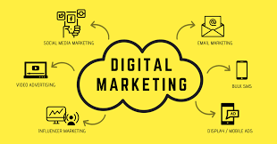

**Digital marketing includes:**

* Email
* Social media
* Web-based advertising
* Text and multimedia messages
* Desktop computers
* Mobile phones
* Other digital media and platforms

Digital marketing differs from traditional marketing in that it uses online channels and methods. It allows you to:

Identify and target a highly-specific audience

Use personalized and high-converting marketing messages

Show ads to a certain audience based on variables like age, gender, location, interests, networks, or behaviours

**The 7 Cs of digital marketing are:**

* Customer
* Content
* Context
* Community
* Convenience
* Cohesion
* Conversion.

Digital marketing originated in India in 1995 when CSNL launched its internet services. It did not perform well initially, as only 0.5% of the population used the internet till 2020.

**1.2 WHAT IS DIGITAL MARKETING?**

Digital marketing is the act of promoting products and services through digital channels, such as social media, SEO, email, and mobile. It is a form of marketing that helps businesses to reach their target audiences, build relationships, and boost sales through digital channels. Digital marketing utilizes a combination of tools such as analytics, social media, content marketing, search engine optimization (SEO), search engine marketing (SEM), email marketing, mobile marketing, and more to create an effective digital presence.

Digital marketing is a powerful way for businesses to reach their target customers and engage with them in meaningful ways. It enables businesses to create personalised messages for their customers, increasing the likelihood of message recall and purchase intent. Additionally, businesses can leverage digital channels to track customer behaviour and identify areas of opportunity. By using digital analytics and other data-driven techniques, marketers can better understand their customers’ needs and preferences and tailor their offerings accordingly. Digital marketing also gives businesses access to a larger audience than traditional marketing channels due to its ability to reach people across the globe.

From creating engaging content to delivering targeted ads with precision, digital marketing is an essential tool for driving business growth and success. It offers businesses the opportunity to reach a large audience in efficient ways while providing customers with personalized messages that build long-lasting relationships.

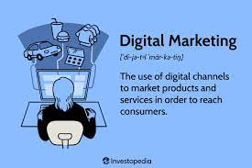**CHAPTER 2**

**2.1 CROMPTON GREAVES CONSUMER ELECTICALS BRAND STUDY**



Crompton Greaves Consumer Electricals Ltd is a leading player in India’s consumer electricals sector with a wide portfolio, which includes fans, lighting, pumps, and household appliances. The company dates it origin back to 1947 when Mr. L K Thapar, an eminent Indian industrialist, took over Crompton Parkinson Works Ltd and Greaves Cotton & Crompton Parkinson Ltd. The company was now part of the Thapar Group. In 1966, these two companies were merged to form CG Power and Industrial Solutions Limited. In 2015, the consumer durables business was demerged to form a separate entity, Crompton Greaves Consumer Electricals Ltd. In FY22, the electric consumer durables segment of CGCEL earned revenue of Rs. 5,453.10 crore (US$ 685.68 million).

Crompton Greaves Consumer Electricals Limited (Crompton) is an Indian electrical equipment company based in Mumbai. The company produces lighting and electrical consumer durables, including: LED lighting, Fans, Pumps, Water heaters, Air coolers, Kitchen appliances.

Crompton's products include: Smart appliances, cooking appliances, Brewing appliances, Room heaters, Electric irons.

In 2020, Crompton's market share in the Indian fan market was estimated to be approximately 21 percent. The company's average share price target is 381.90, which represents an upside of 27.11% from the last price of 300.45.

Crompton was previously a division of a large group. The company divided its electrical sector and consumer sector into two different business segments. Crompton is the name given only for the consumer sector.

| **Year** | **Milestone** |
| --- | --- |
| **2023** | In March 2023, Crompton Greaves Consumer Electricals proposed a scheme of amalgamation of Butterfly Gandhimathi Appliances with the company. This merger is expected to accelerate and smoothen the realization of synergies of the combined business. |
| **2022** | In February 2022, Crompton Greaves agreed to acquire up to 55% stake in Butterfly Gandhimathi Appliances for Rs. 1,379.68 crore (US$ 180.53 million). |
| **2021** | In June 2021, Crompton Greaves Consumer Electricals Ltd. appointed Ms. Pragya Bijalwan as its new chief marketing officer to lead marketing, advertising and the company’s overall communication initiatives. |
| **2020** | Launched new Energion range of ceiling fans powered by ActivBDLC Technology |
| **2019** | Launched new variety of its product |
| **2017** | Became no. two lighting company in the country |
| **2016** | Listing and trading of company on NSE and BSE started in May 2016  Launches sustained brand campaign in April 2016 |
| **2015** | Started operations as an independent entity in October 2015  Consumer business of the company was demerged to form a separate entity |
| **1966** | The two companies were merged to form CG Power and Industrial Solutions Limited |
| **1947** | Crompton Parkinson Works Ltd and Greaves Cotton & Crompton Parkinson Ltd acquired by Mr. L K Thapar, Founder of Thapar Group |

**2.2 CROMPTON COMPETITOR ANALYSIS**

Crompton (also known as Crompton Greaves Consumer Electricals) is a company that manufactures and markets consumer electronics. Some of Crompton's competitors include:

* Pumps: Kirloskar, KSB Pumps, and V-Guard







* Lighting: Philips India, Surya Roshini, Havells, and Bajaj electricals





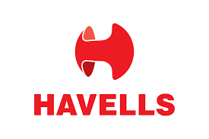



* Other: Summit Electric Supply, Vashi Integrated Solutions, Mob Voi Information Technology, Nardeen Lighting, and Baliga Lighting Equipments.
* The electronics and manufacturing industry is highly competitive. Local and multinational companies compete to gain market share.



Competitive landscape:

The Indian consumer electrical appliances market is highly competitive. The major players are all well-established brands with strong distribution networks. The market is also characterized by a high degree of price sensitivity. As a result, companies are constantly looking for ways to reduce costs and offer competitive prices.

## Crompton Greaves Strengths

1. Wide product range to provide end to end solutions to customers across various segments
2. Major presence in domestic power market and wide installed equipment/customer base
3. Prompt after sales service, good understanding of markets conditions and
4. Geographically wide spread
5. Significant technology absorption and adoption to suit local needs
6. Contemporary integrated manufacture base and infrastructure
7. Highly committed engineering, technical and managerial power

Above are the strengths in the SWOT Analysis of Crompton Greaves. The strengths of Crompton Greaves look at the key internal factors of its business which gives it competitive advantage in the market and strengthens its position.

## Crompton Greaves Weaknesses

1. Technology development constraints
2. Limited financing capacity for large projects
3. High working capitals

These were the weaknesses in the Crompton Greaves SWOT Analysis. The weaknesses of a brand are certain aspects of its business which it can improve.

## Crompton Greaves Opportunities

1. High growth rate will stimulate growth in demand for infrastructure
2. Boost to power transmission sector and privatization moves in distribution sector
3. Total transmission capacity to be increased
4. Reduction of costs

Above we covered the opportunities in Crompton Greaves SWOT Analysis. The opportunities for any brand can include prospects of future growth.

## Crompton Greaves Threats

1. Delay/ Deferment of projects
2. Technology leaders unwilling to share technology
3. International players consolidating and setting up of local manufacturing bases
4. Increasing competition from large companies with strong financial muscle
5. Lowering of import tariffs

The threats in the SWOT Analysis of Crompton Greaves are as mentioned above. The threats for any business can be external factors which can negatively impact its business.

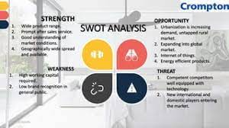

**2.3 CROMPTON BUYER’S/AUDIENCE’S PERSONA**

## **What is a buyer persona?**

A buyer persona is a fictional profile of an ideal customer. It's based on market research and real data about existing customers. Buyer personas are also called: User persona, Marketing persona, Customer persona.

Buyer personas help marketers target their ideal customers. They can help:

* Direct marketing efforts towards the right people
* Avoid wasting time and money on misguided advertisements and content
* Better understand the target market
* Craft marketing messages that resonate with the target market
* Personalize outreach and messaging
* Identify problems buyers may encounter during their customer experience
* Understand the customers your workforce assists
* Align goals across teams to meet consumer needs

Buyer personas are based on real data about: Age, Gender, Income level, Job title.

Other teams that can use buyer personas include: Sales, Customer support, Human resources, Leadership.

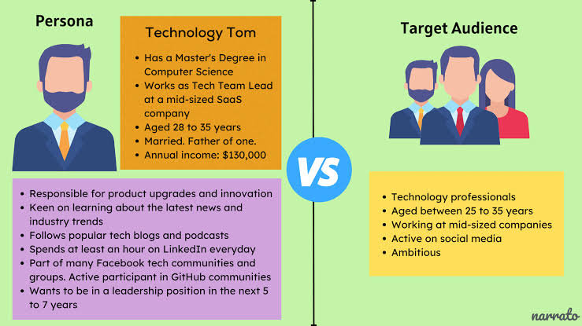

Why a business should establish buyer personas

It’s important for your business to establish a buyer persona because it helps you focus on the needs of your customers. Having buyer personas also help ensure:

* The marketing strategies to acquire customers are planned and implemented with your target audience in mind.
* You provide a customer service experience tailored to your ideal buyer.
* You appeal and connect authentically with your target customers.

When you present your products or services as solutions to your target market’s problems, it’s easier to convince them to buy from you. Read on for more on the benefits of establishing a buyer persona.

Benefits of establishing a buyer persona

Taking time to create a buyer persona can help you expand your market reach and encourage brand loyalty. Here’s why:

* A buyer persona helps you understand your ideal customer. Knowing your prospective customer’s likes, habits, preferred shopping methods, etc., gives you insight on how better to connect with them.
* A buyer persona helps you save on marketing efforts. When you know your target audience, you can design and implement targeted marketing campaigns that will result in more sales without more effort or cost on your part.
* Buyer personas allow you to use segmented marketing. This means you can send personalized, targeted marketing campaigns to each persona.
* A buyer persona helps your business achieve cross-departmental alignment. This means your marketing team, sales team, product development, and customer support departments have the same information about your ideal customer.
* Buyer personas help you connect with your target audience in the right place at the right time. Knowing your target audience means you can meet them in their preferred channel or social media platform.
* Buyer personas help you stand out from the competition. If you’re a business that puts your customers’ needs first, your customers will notice. And this will establish you as a trustworthy brand.
* Buyer personas help identify who you’re not targeting. When you know your potential customers, you can also identify who you’re not targeting. And knowing these saves you from spending resources marketing to the wrong customers.

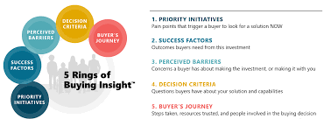

**CHAPTER 3**

**3.1 SEO AUDIT**

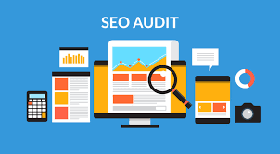

SEO Audit

The SEO audit will include a comprehensive analysis of Crompton Greaves Consumer Electricals' website, including:

* On-page optimization
* Off-page optimization
* Technical SEO

Keyword Research

Conduct a thorough keyword research to identify the most relevant and high-traffic keywords for Crompton Greaves Consumer Electricals.

* Use Google Keyword Planner to identify relevant keywords and their search volume.
* Analyze competitors' keywords and identify gaps in the market.

On-Page Optimization

Optimize on-page factors to improve search engine rankings for Crompton Greaves Consumer Electricals.

* Ensure that the website is mobile-friendly and has a fast-loading speed.
* Optimize meta tags, including title tags, description tags, and header tags, to include target keywords and provide a clear description of the page's content.
* Ensure that the website's content is high-quality, informative, and relevant to the target audience.
* Use alt tags and descriptive file names for images to improve their search engine visibility.

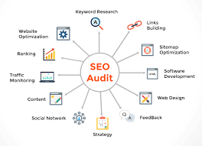

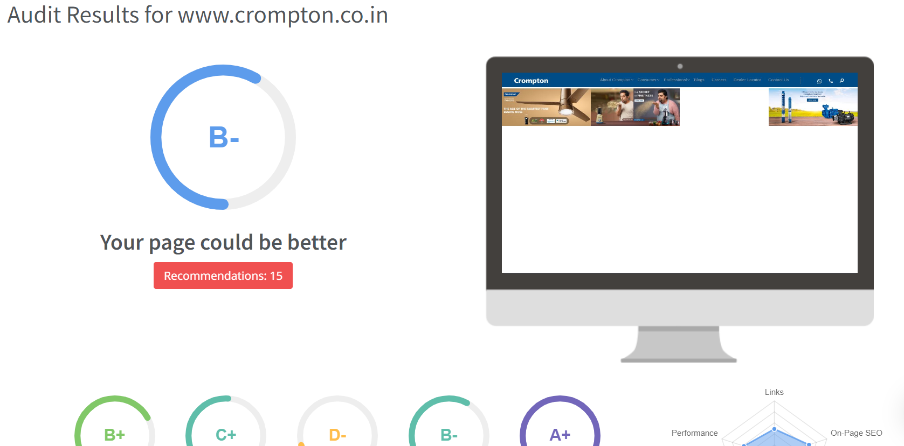

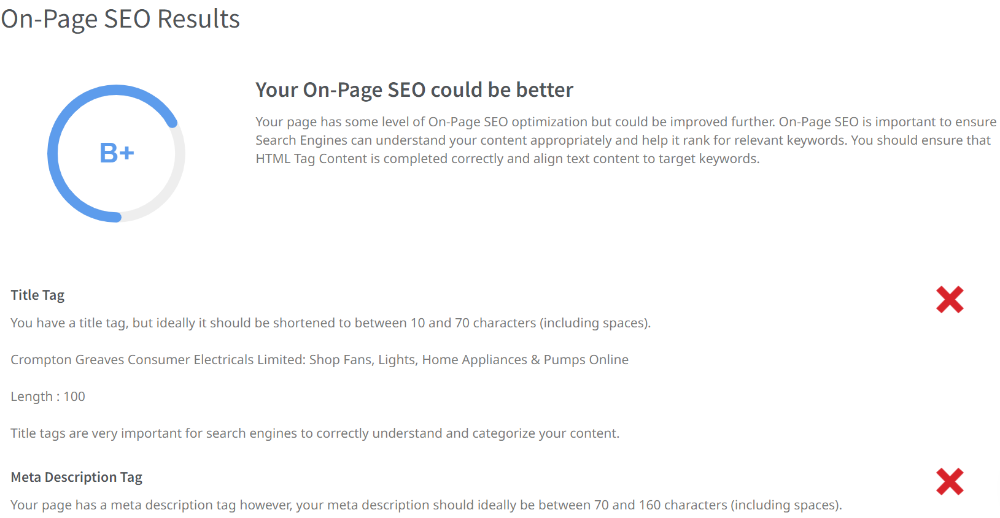

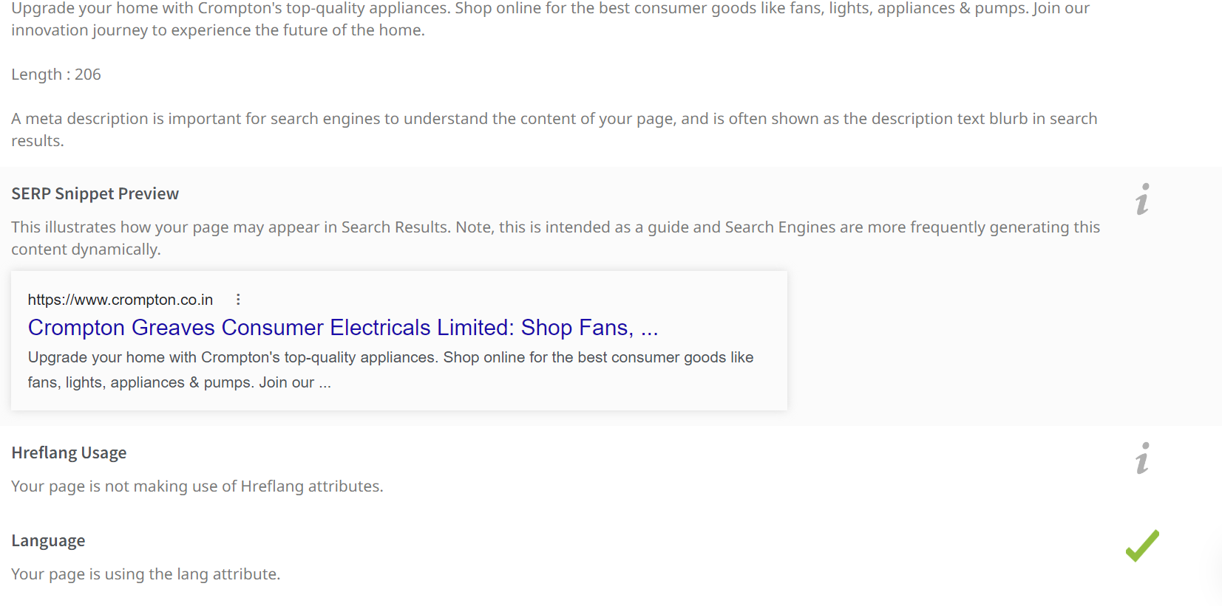

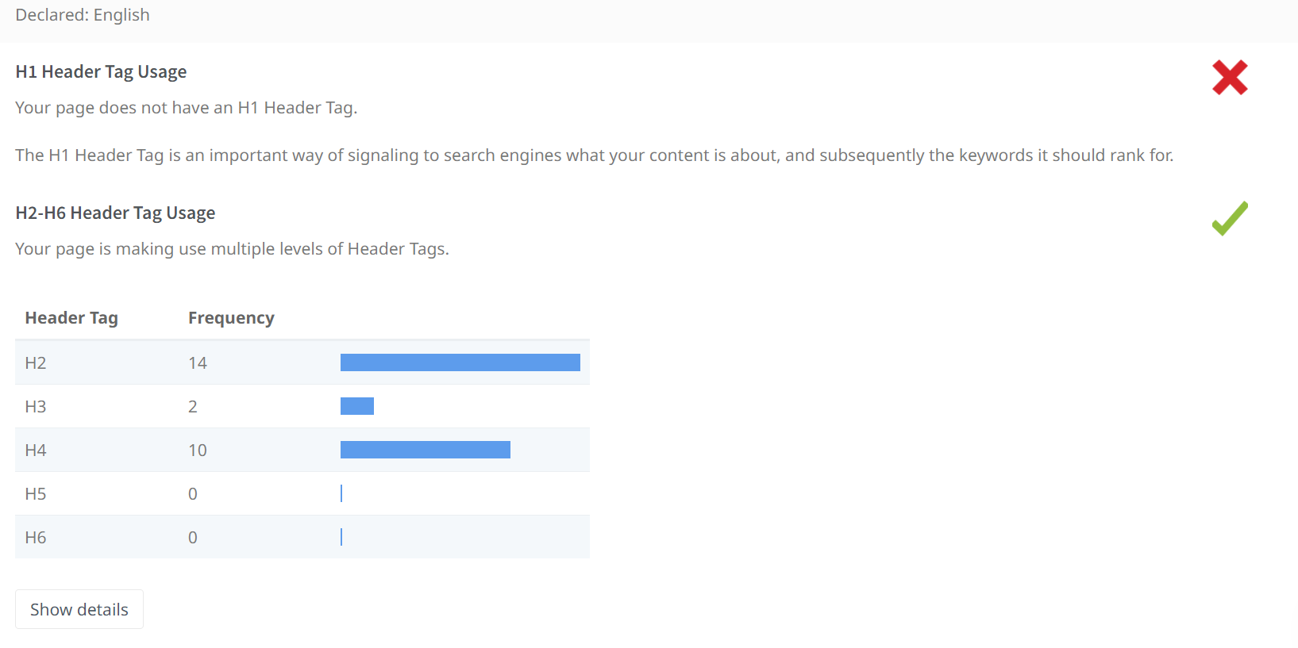

**3.2 KEYWORD RESEARCH**

Keyword research is the process of finding and analysing search terms that people enter into search engines. The goal is to use that data for a specific purpose, often for search engine optimization (SEO) or general marketing.

Keyword research enables you to:

* Target the most effective keywords in your content strategy
* Include popular search terms strategically in your content so that your content appears higher on a search engine results page (SERP)
* Discover valuable search queries that your target customers type into search engines to look for products, services, and information

There are hundreds of tools purpose-built for keyword research. They range from beginner-focused to highly advanced, and from totally basic and unhelpful to super valuable.

Some keyword research tools include:

* Keyword Planner: Find keywords, save your plan, and launch your campaign
* Keyword Overview: Examine keyword search volume fluctuations throughout the year

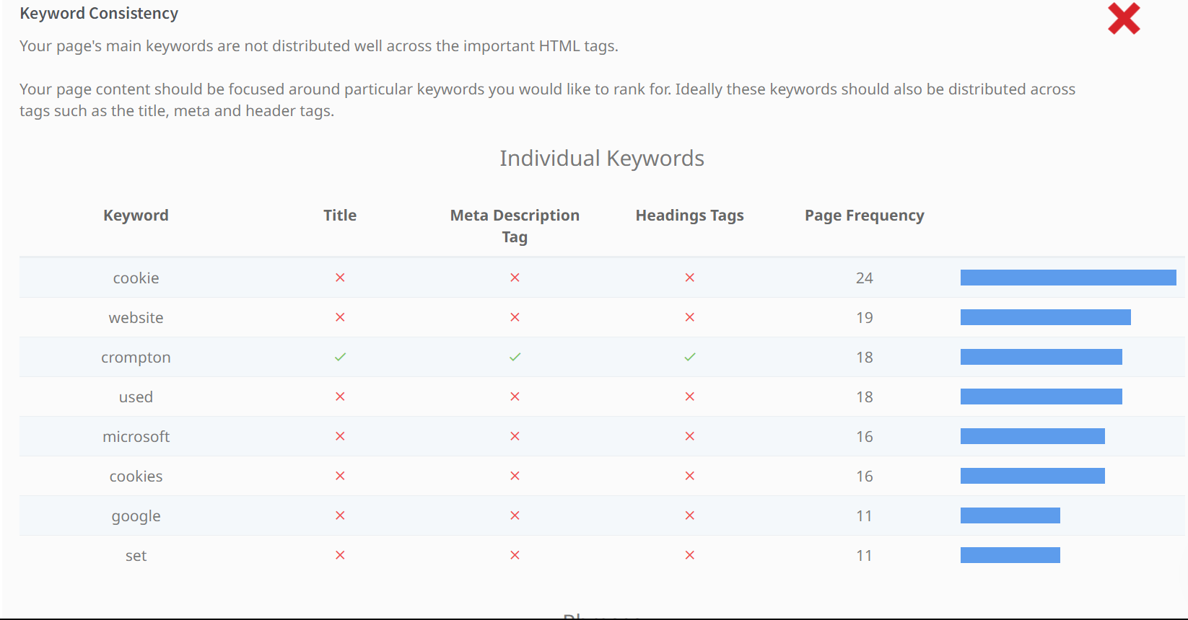

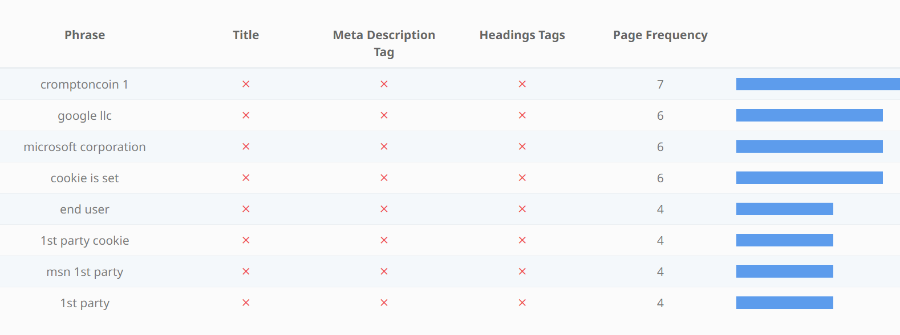

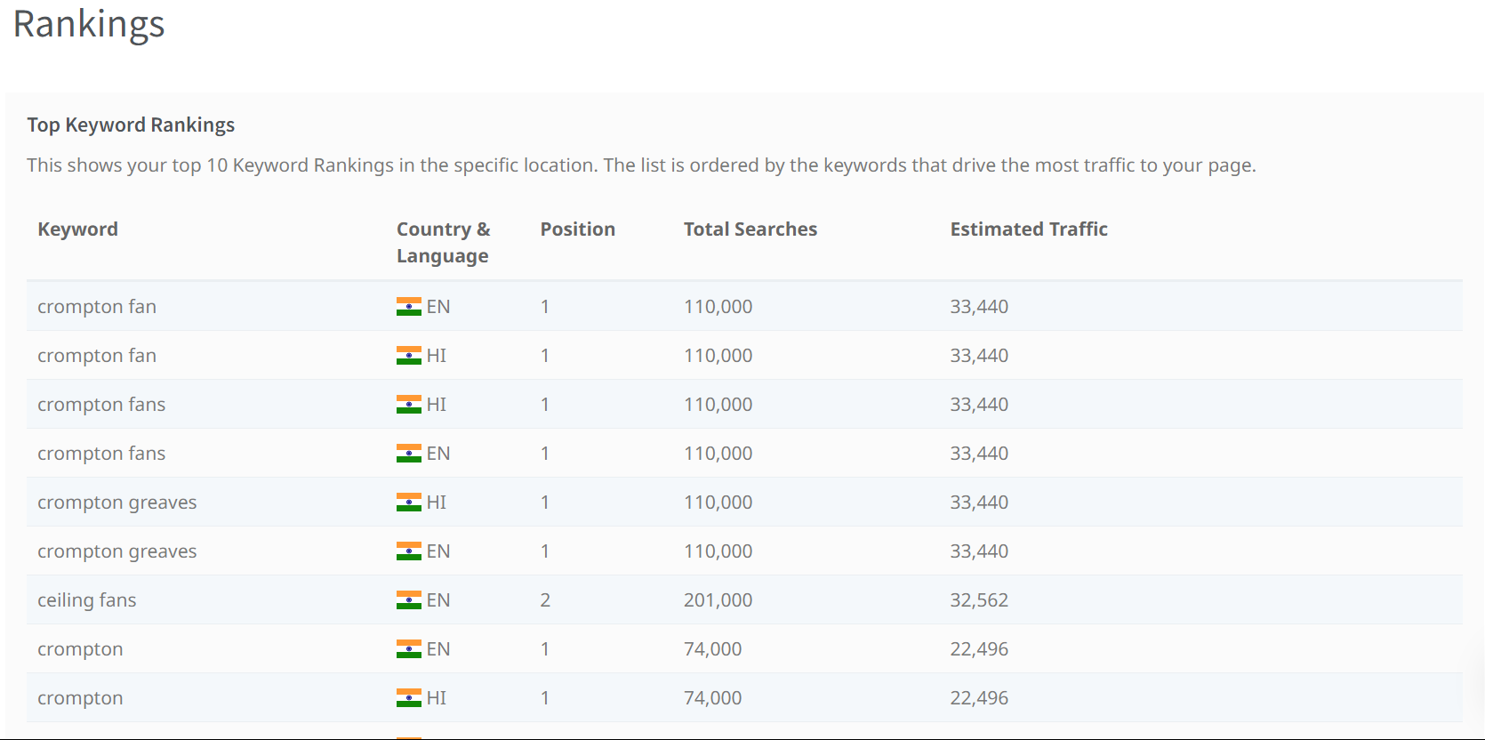 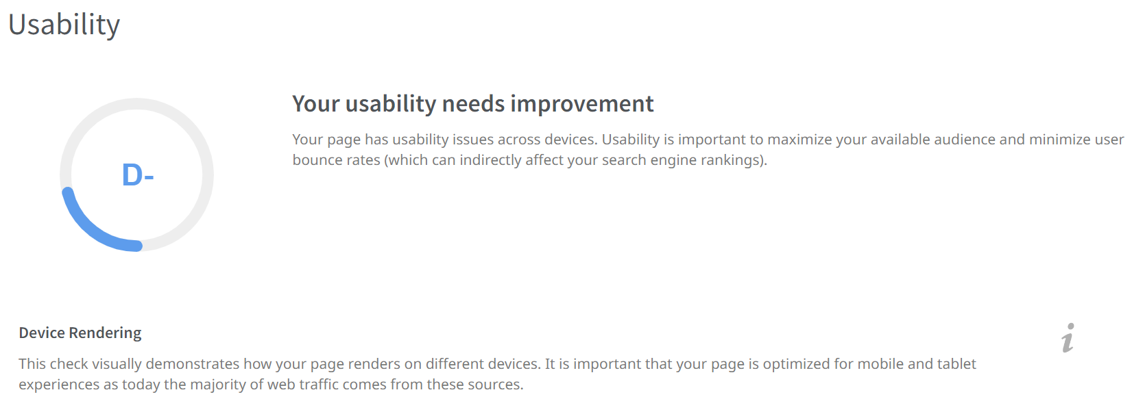

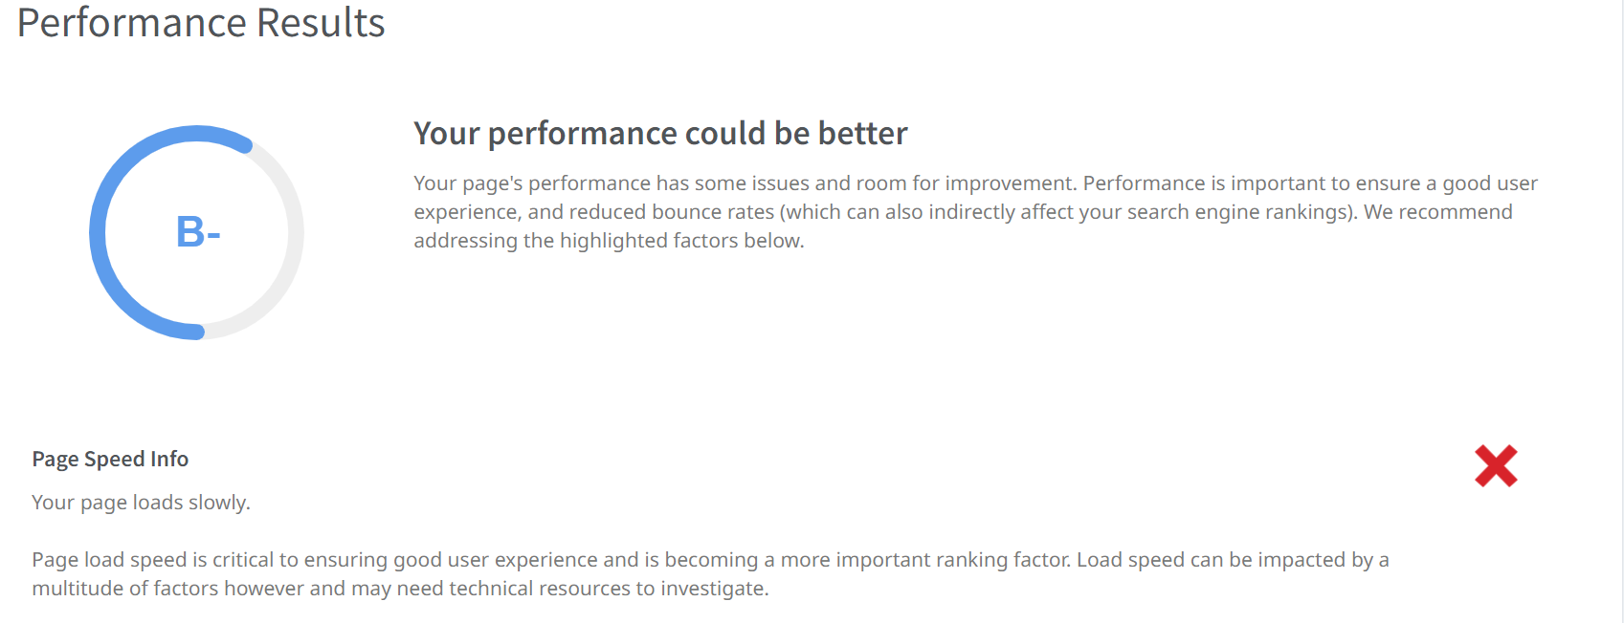

**3.3 ON PAGE OPTIMIZATION**

On-page optimization (on-page SEO) is a type of search engine optimization (SEO) that improves a page's rankings in search results. On-page SEO focuses on a page's content and source code.

Common on-page SEO practices include:

* Optimizing title tags
* Optimizing content
* Optimizing internal links
* Optimizing URLs
* Making sure your keyword is in your URL
* Using headers
* Including keywords in your body copy
* Incorporating images, graphics, and other visuals
* Adding meta description
* Optimizing visuals with alt-text
* Adding internal links

On-page SEO is different from off-page SEO, which optimizes for signals that happen off of your website. Off-page SEO includes:

* Building backlinks
* Gaining exposure through various channels, such as news outlets and social media platforms

Here are some examples of on-page content:

* Text about ceiling fans
* Images of ceiling fans
* Technical specifications on makes and models of ceiling fans

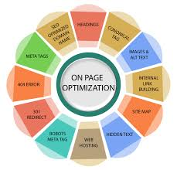

**CHAPTER 4**

**4.1 CONTENT IDEAS**

Here are some content ideas for digital marketing:

* Email marketing: Allows you to stay in touch with customers regularly
* Videos: Can be used to promote new products or services, and can retain users' attention
* Behind the scenes: Show your audience how you create content or what goes on behind the scenes
* Guest blogging: Can promote your brand and improve your website's authority
* Memes: Can be used to connect with an audience
* Ask the audience: You can ask your audience for feedback
* Case studies: Can present problems your audience struggles with and provide solutions
* Collaborate with creators: Can help drive traffic to your website and produce compelling content

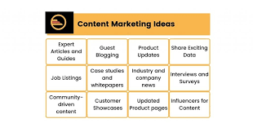

Other content ideas include:

* Turning your top posts into a SlideShare
* Offering a list of benefits
* Sharing a list of things to avoid
* Sharing a “must-do” list
* Highlighting a question of the week
* Doing a weekly links-roundup
* Predicting future trends
* Promoting a seasonal sale

Here are some social media content ideas for digital marketing:

* Build a content calendar: Organize your ideas, allocate resources, and schedule posts.
* Infographics: Add value and are easy to share.
* Host a giveaway: Attract new followers and engage existing followers.
* Interact with your followers: Engage current customers and draw new audiences.
* Content distribution: Content created by users feels more authentic and relatable.
* Create Instagram Reels: Walk followers through a tutorial in a minute or less.
* Curate content: Create engaging content based on your goals, audience, and brand identity.
* Go behind the scenes: Show your audience how you create content or what goes on behind the scenes.
* Other social media content ideas include:
* Sharing your company's blog posts
* Posting about your company's culture
* Highlighting industry news

Asking a question

* Showcasing product or company videos
* Sharing customer reviews and testimonials
* Sharing quick tips and advice

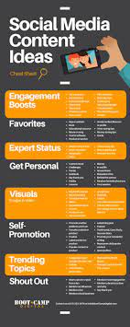 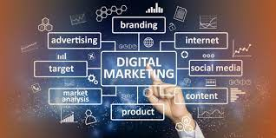

**4.2 MARKETING STRATEGIES**

Digital marketing strategies are plans that use online channels to achieve marketing objectives. These strategies can include:

* Search engine optimization (SEO)
* Pay-per-click (PPC) advertising
* Content marketing
* Email marketing
* Social media marketing
* Voice search optimization
* Video marketing

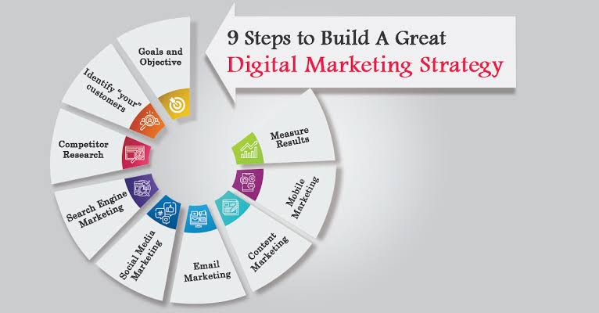

Most digital marketing strategies use a blend of these approaches. For example, you can use:

* SEO-focused blog content on your website
* PR-focused content to earn social shares and coverage
* Paid influencer content

When creating a digital marketing strategy, you should consider factors such as:

* Your target audience
* Your strengths and weaknesses
* Your competitors

You can use data across your business to inform and speculate. You can also integrate the latest online marketing methods into your strategy to increase site traffic.

**Understanding digital marketing strategy.**

**Marketing strategy vs. marketing tactics.**

The term digital marketing strategy often is confused with other related concepts — a true marketing strategy is a comprehensive gameplan that outlines how you’ll reach your target audience and convert them into paying customers. It serves as a blueprint that guides you toward your organization’s unique marketing goals.

Marketing tactics are the specific actions you’ll take to implement your marketing strategy. These may include:

Writing blog posts

Responding to customers on social media

Sending emails

Designing advertisements.

Marketing strategy vs. marketing campaign.

While a marketing campaign goes together with your marketing strategy, it’s important to understand the distinction between the two. A marketing strategy looks at the big picture.

It determines your overall business goals, your customers’ goals, and how you plan to achieve both. A marketing campaign is a promotion that’s designed to achieve one specific objective under your strategy, rather than your overall business goals.

A marketing campaign usually comes with a specific start and end date. You may launch a campaign to promote a new product, generate more traffic, or attract a new customer demographic.

**11 types of digital marketing strategy.**

There are many digital marketing strategies out there. Some deliver better results than others, so we’ll examine the 11 most effective digital marketing strategies used in our current industry.

**1. Inbound marketing.**

Inbound marketing refers to the whole ecosystem of strategies, tools, and tactics that a marketer uses to convert a website visitor into a paying customer. It includes:

Content marketing

Email marketing

Lead nurturing

SEO

Marketing automation

Website optimization

Website analytics.

Inbound marketing is an overall approach to attracting, qualifying, nurturing, and delighting customers and prospects. It is not a one-off or something that is deployed quickly or temporarily; rather, it is focused on a long-term relationship with customers.

**Why use inbound marketing?**

It's affordable. Inbound marketing can save you money while leaving you with a higher ROI. You’ll target a specific group of people rather than anyone and everyone with the hope that you’ll be successful.

Trust and credibility. When prospects and customers do their own research and discover that your content answers their questions, your business is positioned as a trustworthy industry expert rather than just a sales-hungry entity.

Relationship focusses. Through inbound marketing, you can build trusted relationships that not only turn into sales but create repeat customers. Inbound marketing content drives quality traffic to your website and provides visitors with valuable content that encourages them to convert in every phase of the marketing funnel.

**2. Content marketing.**

Content marketing is focused on answering people’s questions and truly helping them through content rather than interrupting them with unsolicited promotions. It includes content such as blog posts, landing pages, videos, podcasts, infographics, white papers, eBooks, case studies, and more.

In most cases, content marketing has several goals. You may use it to:

Increase brand awareness

Improve brand loyalty

Educate your target audience

Convert and nurture leads.

Savvy marketers create content that’s ideal for multiple user personas in all stages of the sales funnel. For example, a user who is unaware of your brand and found your website through organic search needs different content than a prospect who is almost ready to buy. You’ll need to understand your buyers' journeys and come up with unique content that addresses their needs every step of the way.

**Why use content marketing?**

Strong relationships with customers. Content marketing gives you the chance to build a relationship with prospects and customers over time. It also nudges them toward the finish line, making it more likely that they'll choose you over your competitors when they're ready to purchase.

Better SEO. Quality content will significantly improve your website SEO, so you can enjoy more organic website traffic that turns visitors into buyers.

Increased brand authority. When you produce interesting, educational content, you’ll be able to position yourself as an authoritative source in your industry. Your target audience will then turn to you for solutions to any problems they may have.

**3. ABM.**

Account based marketing (ABM) is a powerful B2B marketing strategy that targets specific accounts you select. It’s intended to help sales and marketing teams move prospects through the sales funnel quickly. With ABM, you target the accounts that are most important to you.

**Why use account-based marketing?**

Personalization. ABM does not take a generic approach to marketing. Instead, it creates personalized messaging for target accounts. You use what you know about your customer and tailor your campaign to meet their particular needs.

Collaboration. With ABM, sales and marketing teams work together to identify key accounts and design personalized campaigns for them. ABM encourages teamwork as teams focus on moving accounts through the sales pipeline.

Shorter sales cycles. The B2B sales process is often slow because there are multiple stakeholders involved in making a final purchase decision. With ABM, the sales cycle is expedited because the primary decision maker, and all other relevant prospects, can be nurtured simultaneously with content created specifically for them.

**4. SEO.**

Search engine optimization (SEO) is the process of optimizing your website and your content in order to achieve higher rankings in search engines and increase the amount of organic traffic to your site. It involves a variety of tactics, like:

Creating high-quality content

Optimizing content around keywords and user needs

Incorporating meta information

Ensuring your website is optimized for search engines.

Ultimately, SEO strives to bring in the right visitors organically to drive more leads and sales.

**Why use search engine optimization?**

Higher conversion rates. An optimized website is fast, easy-to-use, and compatible with all devices. Which means it’s more likely to convert users and leave you with loyal customers.

Increased brand awareness. If your content ranks highly in search results, you’ll be able to build brand awareness and trust with visitors. They’ll be more inclined to purchase your products and services than they would if you didn’t have a good web presence.

Long-term cost savings. Once a piece of content is created, it should attract and build increasing traffic over time. You'll still need to produce quality content on an ongoing basis, but you’ll be able to target users who are actively looking for your products and services without an ongoing monetary investment.

**5. Social media marketing.**

Social media marketing uses social media platforms like Facebook, Twitter, LinkedIn, and Instagram to:

Promote your content, products or services

Build brand awareness and visibility

Gain fans or followers

Engage current and prospective customers

Drive traffic to your website.

It requires an ongoing advertising spend and, most of the time, a website landing page designed specifically for users from that ad spend. As soon as your advertising spend ends, the website traffic, likes, and followers end as well.

**Why use social media marketing?**

Cost-effective marketing. With a relatively low budget, you can use social media marketing to expose your audience to your brand even when they’re not thinking about it. You will, however, need to incorporate A/B testing, or some other form of optimization, in order to get the most out of your ad spend and achieve high conversion rates.

Audience interaction. About 45% of the world's population uses social media, and most of them use it about three hours per day. Choose the right channel(s), do some research on how the advertising platform works, and take advantage of the opportunity to interact directly with your audience.

Improved brand loyalty. Research indicates that 71% of people who have a positive experience with a brand on social media are likely to recommend that brand to friends and family.

**6. Email marketing.**

Email marketing is the practice of sending promotional and informational emails to build relationships with your audience, convert prospects into buyers, and turn one-time buyers into loyal fans of your brand.

These emails may discuss exclusive deals, promote website content, upcoming sales, or general messages on the behalf of your business.

**Why use email marketing?**

Traffic to your website. Your emails should contain links to pages on your website. Key performance indicators include the open rate (how many recipients opened your email) and the click-through rate (the ratio of users who click on a link in the email to the number of users who opened the email).

Cost effective. Compared to other marketing strategies like direct mail, SEM or SMM, email marketing usually is cost-effective. Your investment will include a subscription to email marketing software that sends thousands of emails simultaneously, and the cost of someone to administer the program.

Delivers targeted messages. Everyone on an email list has opted-in to receive information. Which means: They want to hear from you! By further segmenting your list, you can deliver super-targeted information that is likely to be well-received.

**7. PPC advertising.**

Pay-per-click advertising or PPC is a strategy in which you (the advertiser) pay every time a user clicks on one of your online ads. It’s often done through Google Ads, Bing Ads, or other search engines, and it can be an effective way to reach people who are searching for terms related to your business.

However, costs can range from relatively inexpensive, to thousands of dollars per month, depending on the size and scope of your campaign. And, when a

campaign is discontinued, the traffic generated by that campaign is also discontinued.

When users click on pay-per-click ads, they are directed to dedicated landing pages that encourage them to take a certain action:

Make a purchase

Complete a form

Download a report, or similar.

If you implement a PPC campaign, your primary goal will likely be to increase sales or leads.

**Why use PPC?**

Easy tracking. With a PPC platform like Google Ads, you’ll be able to track how many people view your ads as well as how many click on them and what percentage of them convert. You'll know instantly how your campaigns perform.

Controlled spend. PPC advertising is pay as you go. You’ll be able to change or pause ad campaigns that are underperforming, and you don’t have to commit to a certain advertising spend.

Instant results. Other marketing strategies like SEO and content marketing take time to work. PPC advertising, however, offers a fast way to set up a campaign and get results right away.

**8. Video marketing.**

Video used to promote your products, services, and brand may include product demos, interviews with thought leaders in your industry, customer testimonials, or how-to videos.

You can add videos to your website, PPC landing pages, or social media outlets to encourage more conversions and sales.

KPIs may include:

Engagement. Time spent watching the video.

View count. How many times it was watched.

Click-through rate. How many users clicked through to the website.

Conversion rate. Number of leads, prospects, or customers content generates.

**Why use video marketing?**

Improved SEO. Marketers are 53 times more likely to end up on the first page of Google results if they utilize a video on their website, because including a video in a website improves SEO, which improves the page's rank.

Increased conversion rates. When marketers include video on a landing page, it can increase conversion rates by up to 34%.

Improved brand association. In addition to better conversion rates, brand association increases 139% after watching a video. When consumers watch a video, 92% share that video with others.

**9. Online (and in-person) events.**

There’s nothing like an event to create buzz around a product. Of course, trade shows have always been a thing, most notably the International CES tech show. But Apple redefined such events for an online audience with its series of high-profile iPhone and Mac launches throughout the 2010s and into the 2020s, often watched by up to 1.8 million people.

It’s unlikely you’ll reach such engagement levels, but there are nevertheless lessons to learn, whether you’re using an event to launch a product, service, or new business.

**Why use online events?**

Build anticipation. Use social posts ahead of the live event to create buzz about what you might be launching. Consider the way Apple teases small details of its new iPhone, such as a photo of small section of the device, in the days before.

Showcase your product. If you’ve dedicated your live event to one product, then that product will be the focus of people’s attention. Use that attention to tell stories about its features in the same way Steve Jobs once did for Apple products.

Stimulate conversation. Run a live stream of the launch, push out a press release and create a hashtag of the event to get people talking about your product. Consider how Apple uses hashtags like #AppleEvent to trend on Twitter.

**10. Chatbot and live chat marketing.**

Chatbots and messaging apps have become more common in the past decade and are now seen as a valuable marketing, as well as customer service, tool. Some 1.4 billion people who use messaging apps are happy to speak with chatbots. Brands use chatbots to:

Deal with customer complaints

Answer questions about products

Promote live events

But despite these different uses it’s worth considering research from chatbot platform Drift. It says the number one predicted use for a chatbot is ‘getting a quick answer in an emergency so perhaps keep your chatbots simple.

**Why use chatbots?**

Provide quick answers. People go online with a task in mind. They want an answer fast. Chatbots can help people to get quick answers and resolve complaints, which can have a positive impact on brand sentiment.

Enhance customer experience. People told Drift they would use a chatbot to ‘get detailed explanations’ and to ‘find a human customer services assistant. Both help to improve a customer’s experience with your brand.

Sell your products. A chatbot might seem an odd place to convert sales. But 18% of people said they would buy a basic item through a chatbot, while 22% would use one to explore ideas for purchases.

**11. Earned media.**

Put simply, earned media is coverage of your business, products or events written by a third party and which you have not paid for. In digital marketing, it’s best described as PR which you outreach to the media. When the content is picked-up by a publication and written up for their own site, that’s earned media.

Examples of earned media include:

Tactical PR, such as newsjacking topical events

Traditional press releases on company news

Infographics based on survey data

Creative asset such as an interactive site.

**Why use earned media?**

It’s free. Once you’ve paid your staff or an agency to outreach your content, any coverage you secure from websites is free. This makes it a cost-effective digital strategy and frees up budget for future campaigns.

It’s scalable. Earned media can be delivered for any budget. From a simple tactical piece, such as issuing quotes to a newswire on a topical issue, to a bigger creative campaign, such as a site build or conducting a survey.

It’s good SEO. Getting backlinks to your site from trusted publishers and institutions can be worth its weight in gold. Google ranks sites by their DA (Domain Authority) and sites with higher DAs, such as colleges and news sites, can help to improve your own authority.

**How to build a digital marketing strategy.**

Now it’s time to build a digital marketing strategy, you need to pull everything together. Regardless which of our 11 digital marketing strategies you have chosen, establishing goals, defining audiences and establishing what you need to create is vital.

**1. Set goals and objectives.**

Before you decide on a digital marketing strategy, establish and document your short- and long-term goals. After you decide on your strategy, outline and document specific objectives so you'll know if your strategy is working. Make sure your goals and objectives are SMART (specific, measurable, attainable, relevant, and timely).

Goal. Increase awareness of our widgets among our target audience.

Strategy (how you'll achieve the goal). Use content marketing to persuade buyers that our widgets are the best in the market by creating content for at least two user personas in every step of the sales funnel.

Objective (how you'll know if the strategy is working). Achieve a 25% increase of downloads of our widget whitepapers and eBooks each quarter and boost email subscribers by 50% in 6 months.

Document all your goals, strategies, and objectives so that you can refer to them when it’s time to measure success.

**2. Consider buyer personas.**

It’s impossible to create an effective digital marketing strategy unless you understand the people you’re trying to target. That’s where buyer personas come in. Buyer personas are fictional people who represent the traits of those you’d like to buy your products or services.

Personas should be rooted in data and research. Using your own intuition to create personas with no data behind it can lead to the wrong focus. So that means you need to speak with your customers through in-person, app, or telephone interviews and surveys.

Things to feed into your personas:

Location. You can use web analytics tools to see where your customers are shopping from.

Income/occupation. Ask customers if they’re happy to disclose details of their income and occupation.

Hobbies/interests. Online forms or focus group-style sessions could help to show what people are interested in. While you could also use search trends to explore popular hobbies for certain demographics.

Goals/aspirations. What do your customers want? What drives them? Focus groups and surveys can help you to establish this. Existing consumer reports/data are another good source.

Challenges/pain points. What is it that gets in the way of them achieving their goals? Speaking to customers as well as your own sales teams can help you to understand this.

Once you’ve created several personas, you’ll find it easier to market to different types of buyers and cater to their needs.

**3. Audit your assets.**

Gain a thorough understanding of what your business already has by documenting your current digital assets. Then, dive deep into each one and rank it from most-effective to least-effective. Once you do, you’ll know which assets need to be improved, and which ones need to be rebuilt from scratch.

Let’s look at the example of an SEO focused content audit. Key elements include:

Crawl the site. Gather all the URLs across your blogs, category pages, and other relevant pages.

Identify gaps. From the list of URLs, try to establish any clear content gaps based on your personas and campaign objectives.

SEO insights. Work with an SEO to gauge performance of the existing URLs and also new opportunities from keyword research.

Compile the data. Pull all this data into a spreadsheet so you can see all the key information presented side by side.

Create tasks. Compile recommendations for improving existing pages and also a plan for the new pages you need to create.

4. Plan your content creation resource.

To stay with the example of a content marketing campaign, once you have established what needs to be created, you’ll need to establish how that work will be executed and delivered. This generally means considerations around:

Budget. How

much money do you have to spend on this campaign? Is it enough to create all the assets in your audit or do you need to compromise?

Resource. Do you have the right skillsets to create this in house? Or do you need to appoint an agency?

Tech. Does the campaign require any specialist software? For example, a content management system or personalization tool?

Deadlines. How soon does this content need to be created? Even if you have in-house resource will they have time?

Once you’ve considered the above alongside your objectives, personas, and audit you can finalize your plan for exactly what content you will create and any additional resource you’ll need.

**5. Decide how to distribute your content.**

With personas confirmed, content creation under way, and resource in place, the next thing to decide is how you will distribute your content. The main consideration is whether you consider the content to be:

Owned. Channels owned by you, include website, blog, email, social.

Earned. Content others share, like, comment on or write about.

Paid. Content you have paid to promote, such as PPC and influencers.

Most digital marketing strategies will use a blend of each of these approaches. For example, using SEO-focused blog content on owned channels such as their website, earned social shares and coverage with PR-focused content and putting budget behind paid influencer content.

**6. Pinpoint your KPIs.**

Any digital marketing strategy should be measured continuously. Identify key performance indicators or KPIs, which are measurable values that gauge the effectiveness of your strategy and tactics. Some examples of KPIs include:

Digital conversion rates

Cost per lead

Returning website visitors

Click through rates

Customer lifetime values.

Once your digital marketing campaign concludes you can hold a wash-up meeting with all relevant parties to share data around its successes and failures, which can feed into future digital marketing strategy planning.

Digital marketing strategy: Final words of advice.

Digital marketing is constantly evolving, and it can be difficult to keep up with the latest trends. It can also be tough to create engaging content and break through the clutter. After all, there may be dozens or hundreds of brands promoting their offerings to your target audience.

To ensure your digital marketing strategy drives results:

Create content that provides answers to your audience's questions or needs

Leverage your network and expertise

Keep an eye on what your competitors are doing

Subscribe to Google Alerts and industry blogs on digital marketing.

Also, don't be afraid to try something new, or ditch something that's not working. One of the best things about a digital marketing strategy is that it is immediately measurable. Double down on what's working, and end what is not working.

Frequently asked questions about digital marketing strategies.

What is the most effective digital marketing strategy?

The most effective digital marketing strategy is the one which aligns best with your brand, audience, and campaign objectives. This could be a content marketing strategy which uses content such as blogs and whitepapers to engage audiences, or an event-based strategy which creates buzz around product launches and trade shows to earn media and grow engagement. There are many other options too, and brands will often combine several approaches into their overall digital marketing strategy.

**What is a definition of digital marketing strategy?**

A good definition of digital marketing strategy is that it is a strategy put in place by a brand to align with set objectives and goals to attract a specific type, or types, of customer using a combination of marketing techniques. These techniques include content marketing, social media marketing, earned marketing, and more.

Learn more about effective digital marketing strategies.

Many businesses choose to work with a trusted partner and invest in software solutions as they create a digital marketing strategy. If you’re ready to bring your strategy to life, Adobe Experience Cloud provides solutions for content management, campaign execution, personalization, lead management and more.

When you're ready to ramp up your digital marketing strategy, Adobe provides end-to-end digital marketing, enabling you to manage, personalize, optimize, and orchestrate cross-channel campaigns across B2B and B2C use cases. Request a demo today to see what Adobe Experience Cloud can do for you.

**CHAPTER 5**

**5.1 CONTENT CREATION AND CURATION**

**1.Product Highlights:**

Regularly feature and highlight different products in your catalogue.

Share customer reviews and testimonials related to these products.

**2. Industry News:**

Curate news articles, reports, and updates about the electrical and consumer appliances industry.

Provide insights or commentary on significant developments in the industry.

**3. Energy Efficiency Tips:**

Share tips and content from reputable sources on how consumers can save energy using your products.

Explain the benefits of energy-efficient appliances.

**4. DIY and How-to Guides:**

Curate and share DIY projects, installation guides, and maintenance tips related to your products.

Collaborate with influencers or experts to create original how-to content.

**5. Customer Stories:**

Showcase stories and experiences from satisfied customers who have benefited from Crompton Greaves products.

Share user-generated content, with permission.

**6. Sustainability and Green Initiatives:**

Curate content related to sustainability, environmental initiatives, and green technology in the electrical industry.

Highlight your company's sustainable practices and products.

**7. Infographics and Visual Content:**

Share visually appealing infographics and charts related to electrical efficiency, product comparisons, or industry statistics.

**8. Trend Analysis:**

Curate content that analyses industry trends, market insights, and emerging technologies.

Provide your perspective on how these trends might affect consumers.

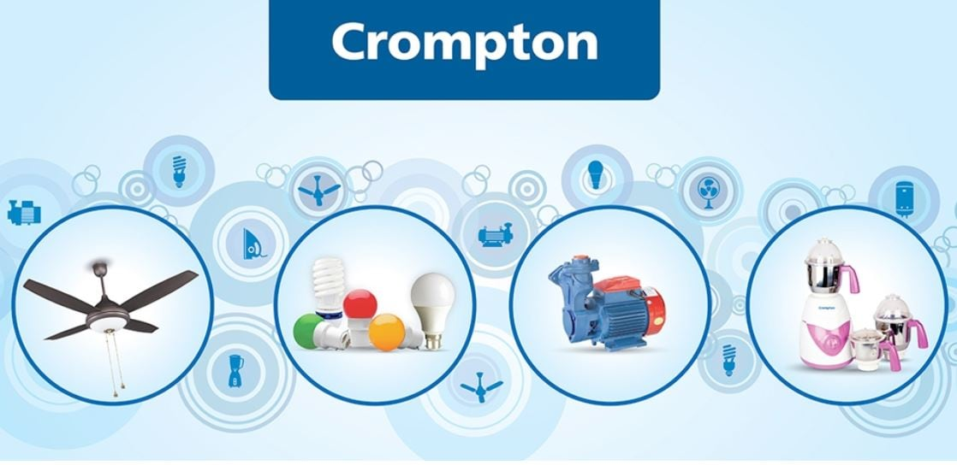

**9. Case Studies:**

Curate and share case studies that demonstrate how your products have addressed specific consumer needs or solved problems.

**10. Educational Content:**

Curate articles, videos, or guides that educate consumers about various aspects of electrical appliances and technology.

Provide commentary or additional insights to make the content more valuable.

**11.User-generated Content:**

Encourage customers to share their photos and videos using your products. You can then curate and showcase this content on your social media and website, with proper permissions.

**12. User Content:**

Continuously monitor social media for user-generated content related to your products.

Share and acknowledge these user contributions, fostering a sense of community.

**13. Holiday and Seasonal Content:**

Curate content relevant to holidays, seasons, and events that showcase how your products fit into these occasions.

**14. Collaborations and Partnerships:**

Curate content that promotes collaborations with other companies or organizations.

Highlight how these partnerships benefit consumers.

**15. Educational Resources:**

Curate online courses, webinars, or informative content from external sources that can enhance consumer knowledge about electrical appliances and safety.

When curating content, always ensure that the content is relevant, accurate, and aligns with your brand's values and objectives. Curation should be a strategic effort that complements your original content and provides additional value to your audience. Remember to give credit to the original sources and seek necessary permissions when sharing content created by others.

Creating and curating content for Crompton Greaves Consumer Electricals, a company that specializes in electrical appliances, can be an effective way to engage with your target audience and promote your pro